WORKSHEET 6

**Student Name: Priyansh Tyagi UID: 20BCS5670**

**DOMAIN CAMP:** 03-01-2023 to 14-01-2023 **Section/Group:** DWWC-43

**Subject Name:** IT Skills (DSA)

Question 1. FAMILY TREE

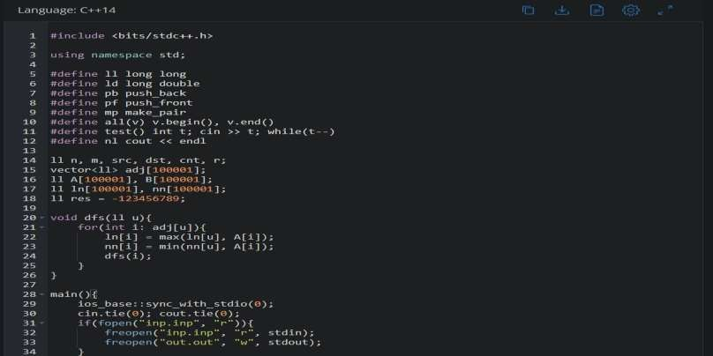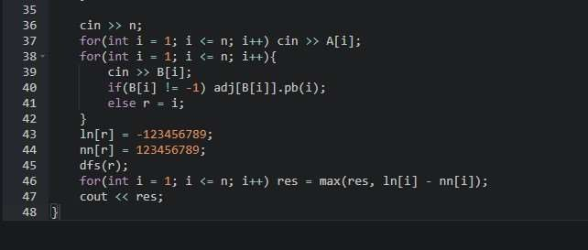

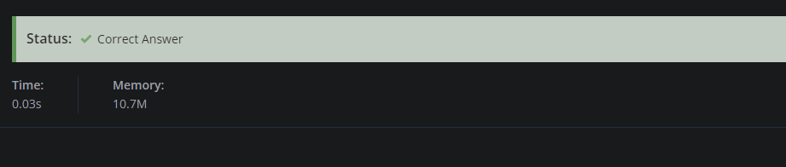**SOLUTION:**

Question 2. SHORTEST PATH IN BINARY TREES

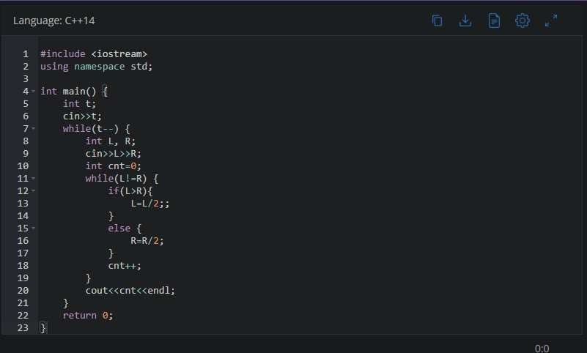

**SOLUTION:**

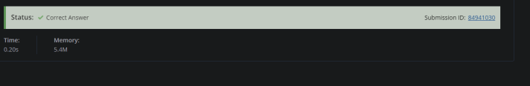

Question 3. BLACK AND WHITE TREE

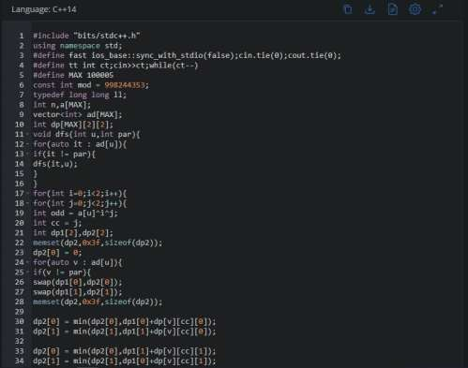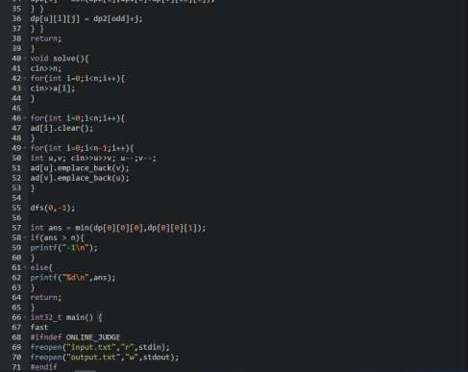

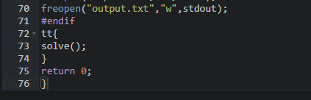

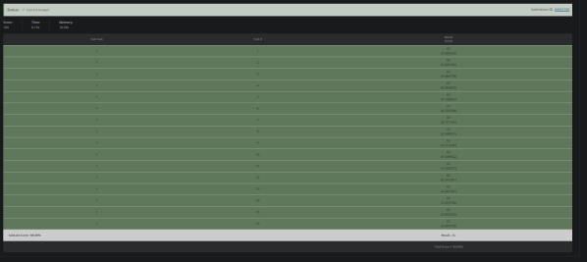**SOLUTION:**

Question 4. SECRET TREE

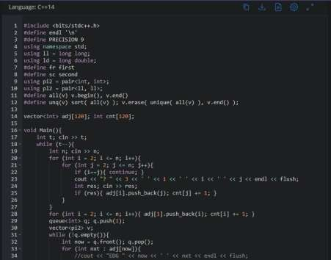

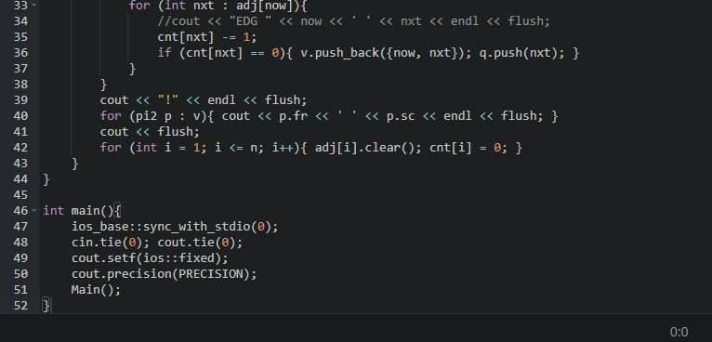

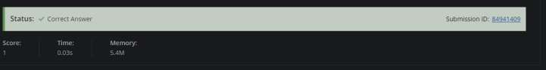**SOLUTION:**

Question 5. BLACK AND RED VERTICES OF TREE

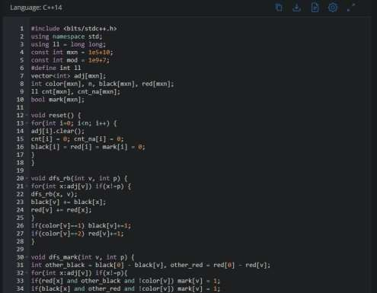

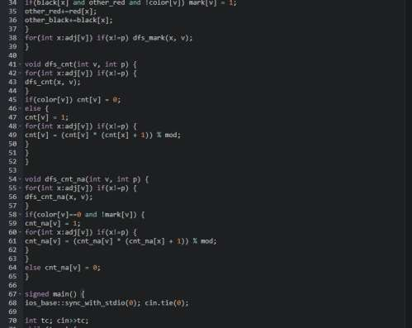

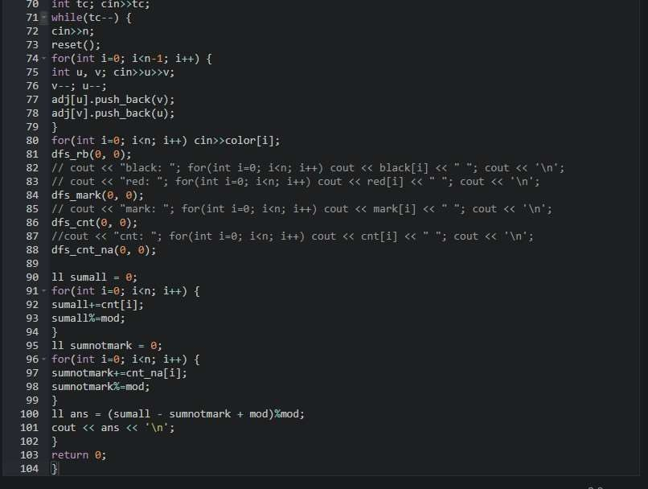

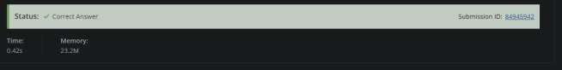**SOLUTION:**

Question 6. COMMON ANCESTORS

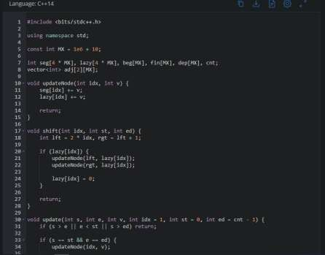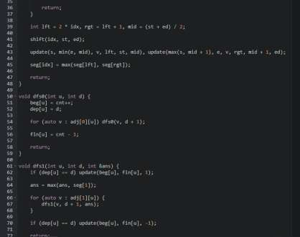

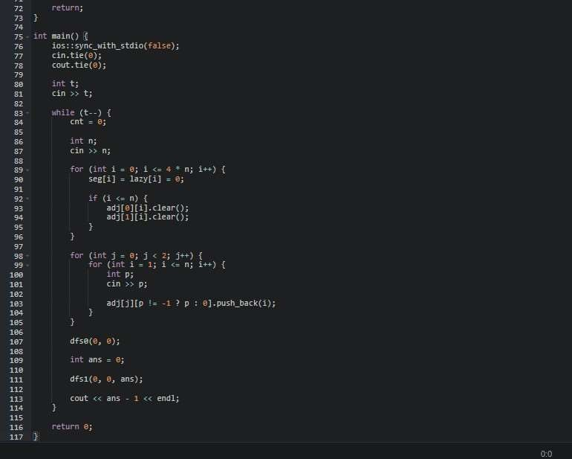

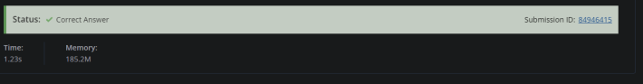**SOLUTION:**

Question 7. SUBTREE REMOVAL

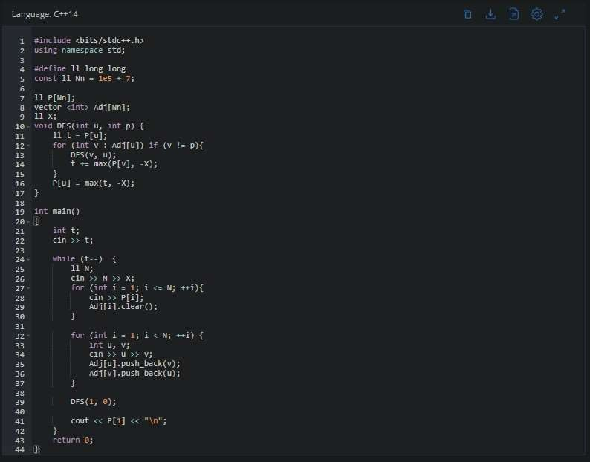

**SOLUTION:**

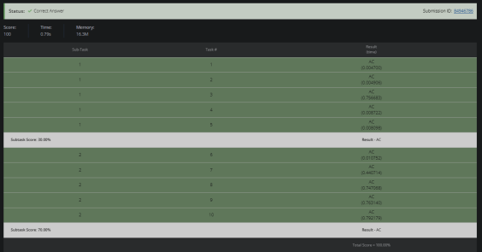

Question 8. ALTERNATING DIAMETER

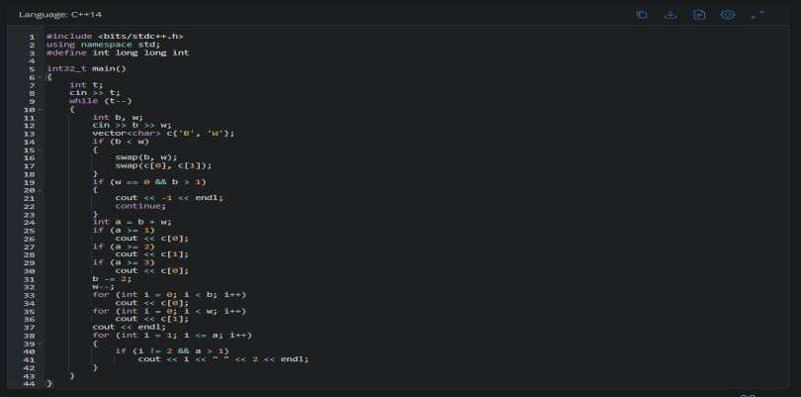

**SOLUTION:**

